Appointment Application Documentation

This application used for creating, reading, updating and deleting appointments.

Port = 8082

JAVA version = 8

DATABASE= H2 Database

**Steps to execute the App**

1. **Download source code from** [**https://github.com/mithileshs66/Appointment-Application.git**](https://github.com/mithileshs66/Appointment-Application.git)
2. **Import the source code into your IDE and execute the code.**
3. **Download All dependency and library using maven ->update right click on file.**

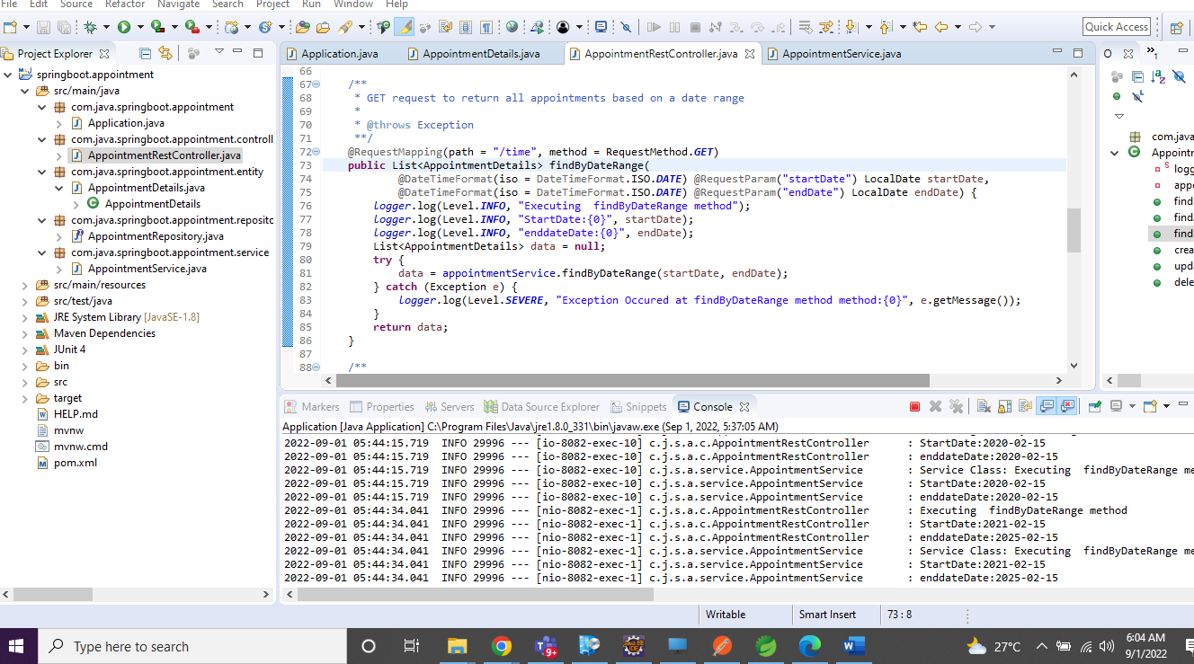

1. **Also download the postman API collection and import the collection directly to your postman**

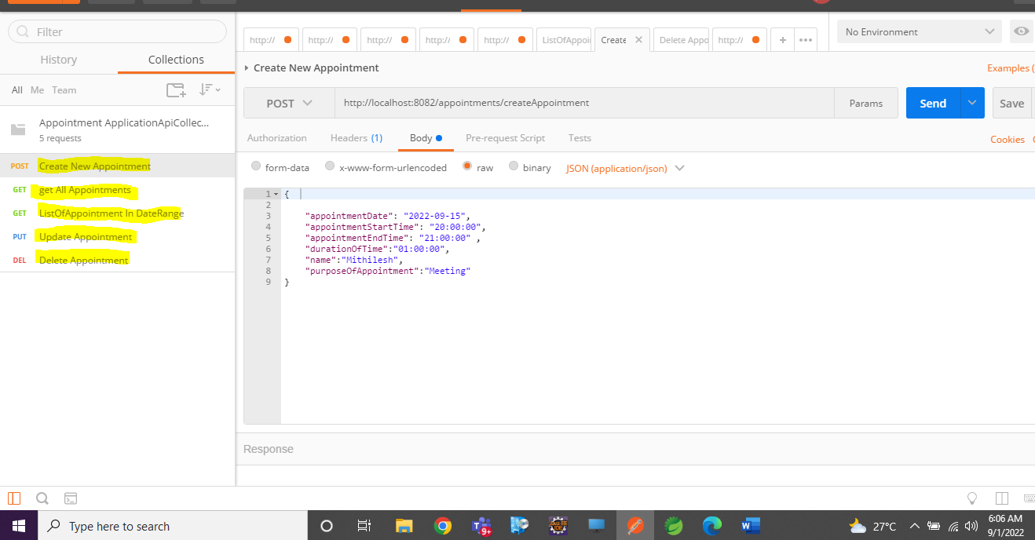

1. **As we are using H2 database , So data will be lost once Session is over.**

**API Details**

**1.This API used for creating Appointments**

***API:*** [***http://localhost:8082/appointments/createAppointment***](http://localhost:8082/appointments/createAppointment)

***Method: POST***

***Payload: {***

***"appointmentDate": "2022-09-15",***

***"appointmentStartTime": "20:00:00",***

***"appointmentEndTime": "21:00:00" ,***

***"durationOfTime":"01:00:00",***

***"name":"Mithilesh",***

***"purposeOfAppointment":"Meeting"***

***}***

***Sample ScreenShot***

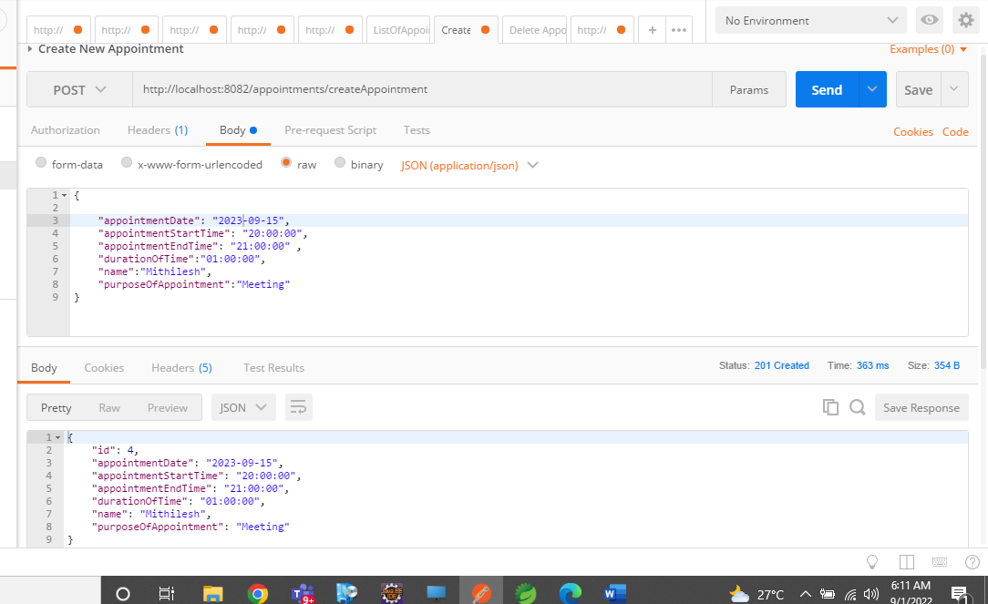

**2. This API is used to get All Appointments**

***API:*** *http://localhost:8082/appointments/getAllAppointment*

***Method: GET***

***Sample Screenshot:***

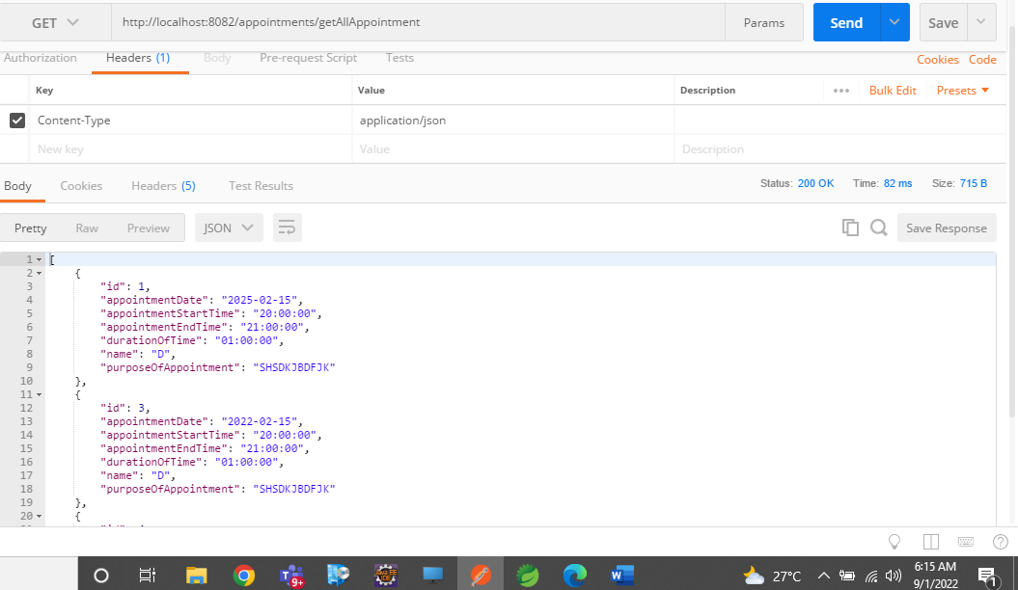

**3.This API is to give List of Appointments in a given Date Range**

***API:*** *http://localhost:8082/appointments/time?startDate=2021-02-15&endDate=2025-02-15*

***Method: GET***

***Sample Screenshot:***

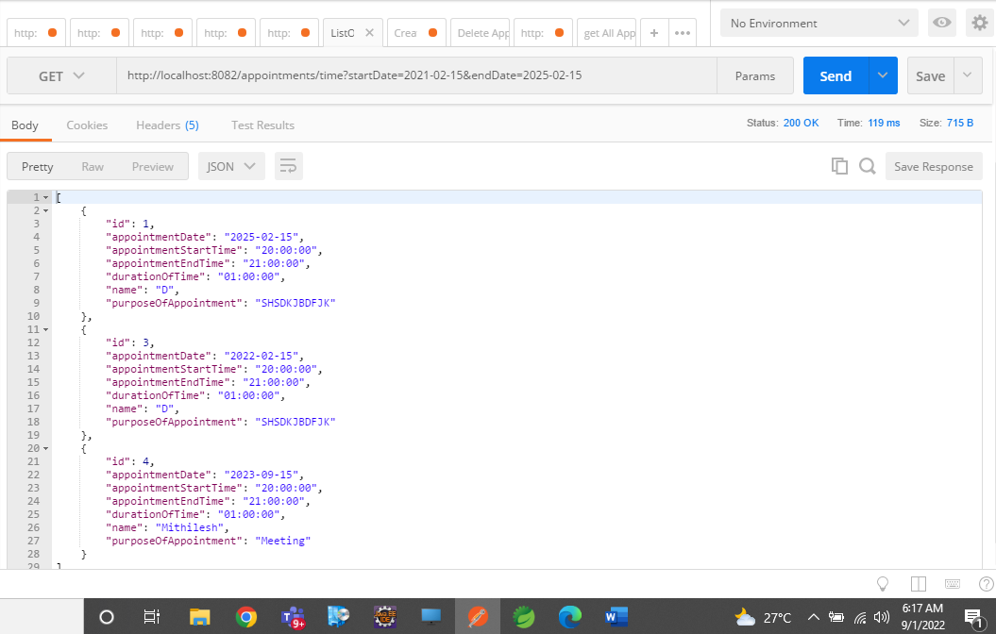

**4.This API is used for Updating Appointment by ID**

***API*** *http://localhost:8082/appointments/update/1*

***Method: PUT***

***Sample Payload: {***

***"appointmentDate": "2026-02-15",***

***"appointmentStartTime": "20:00:00",***

***"appointmentEndTime": "21:00:00" ,***

***"durationOfTime":"01:00:00",***

***"name":"D",***

***"purposeOfAppointment":"Meeting"***

***}***

**Sample Screenshot:**

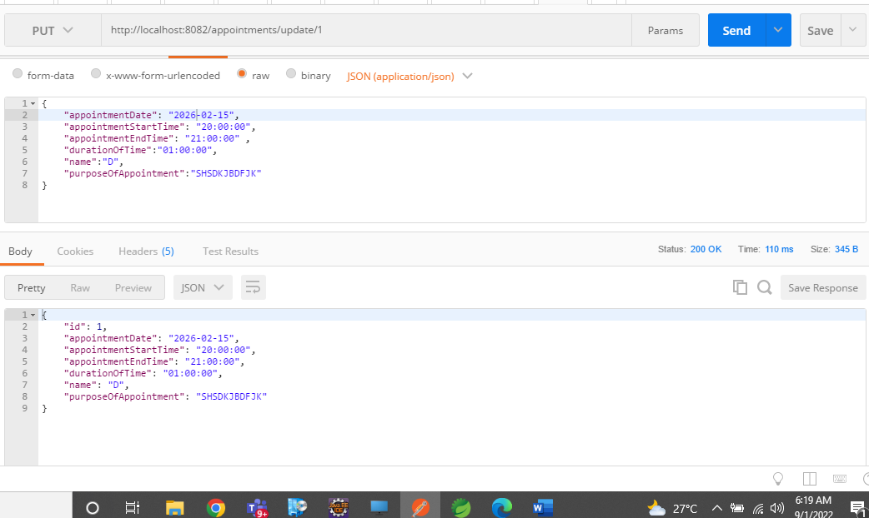

1. **This API is Used For Deleting Appointment by Id**

**API** http://localhost:8082/appointments/delete/3

**Method: DELETE**

**Sample ScreenShot:**

